1. Model a scenario of the Withdraw Money use case of a Bank ATM system. The user is able to make withdrawal of money. The system employs a standard procedure of validating the card and account holder’s password.

- Describe the main objects (2 in this case):

- Cardholder (or Customer)
- ATM System

- Describe the main flow of events in this scenario. The first 2 events are listed below:
[8 Marks]

- Customer arrives at the ATM machine and inserts a bank card.
- The system requests for user authentication (request PIN number).
- Customer insert PIN number.
- Customer select service from menu for withdrawal.
- Customer select account whether savings or current account.
- Customer enter the amount for withdrawal.
- The system and machine will eject the customer’s card.
- The system will dispense money from the machine.
- The system will print receipt.
- The use case ends.

- Translate the flows into corresponding system events (sequence diagram).
[12 Marks]

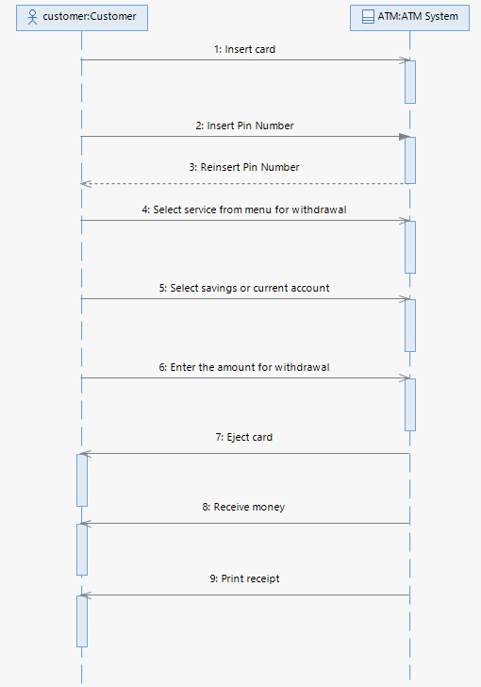

2. Now model the scenario of the Withdraw Money use case in more detail. Elaborated in more detail by including new internal objects of the withdraw money use case such as Card Controller (to control card management) and Bank (the issuing bank).

a. Main objects
    - User / Customer / Cardholder
    - ATM System
    - Cash Dispenser
    - Card Controller
    - Bank
    - Account

b. Describe the main flow of events in this scenario. The first 2 events are listed below:
[10 Marks]
- User arrives at the ATM machine and inserts a bank card.
- The card is verified by the Card Controller.
- The ATM accepted the card.
- The system requesting authentication from card holder.
- The user insert PIN number to the ATM.
- The bank verify the PIN number.
- The ATM system receive PIN number verification.
- The cardholder (user) request for service.
- The user select withdraw from ATM system.
- The cardholder prompt with amount from the ATM system.
- The cardholder insert the amount to the ATM system.
- The account will check balance is it the amount insert is sufficient for withdrawal.
- The account will deduct the amount for cardholder amount for withdraw.
- The card controller with eject the card back to the cardholder.
- The cash dispenser will dispense money to the cardholder.

3. Translate the flows into corresponding system events (sequence diagram).
[30 Marks]

